|  |  |  |  |
| --- | --- | --- | --- |
| **NAME:** |  | **INDEX NO:** |  |
| **SCHOOL:** |  | **SIGNATURE:** |  |

**535/3**

**PHYSICS**

**PRACTICAL**

**🕮**

**🖎**

**Community**

UNNASE MOCK EXAMINATIONS

**Paper 3**

**2 ¼ hours**

**Uganda Certificate of Education**

**PHYSICS PRACTICAL**

**Paper 3**

**2 hours 15 minutes**

**Instructions to Candidates:**

* Answer question 1 and one other question.
* You will not be allowed to start working with the apparatus for the first quarter of an hour.
* Marks are given for clear record of the observations actually made for their suitability and accuracy and for the use made of them.
* Whenever possible, candidates should put their observation and calculations in a suitable table drawn in advance
* Graph papers are provided

1) In this experiment you will determine the density of the liquid L. 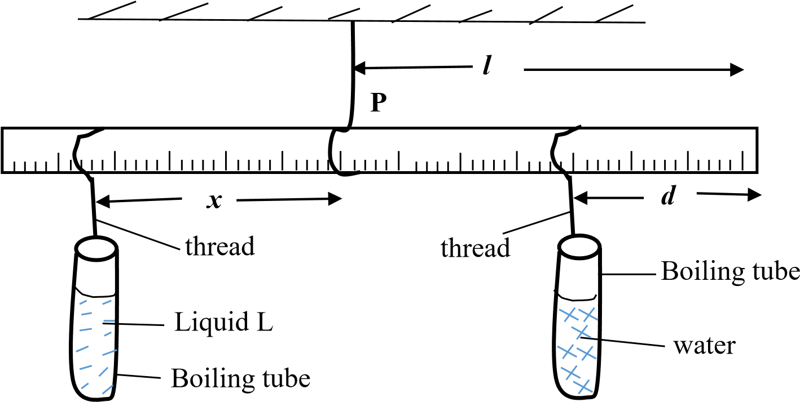**B**

* 1. Suspend the metre rule from a retort stand using a piece of thread so that the rule balances horizontally.
  2. Note and record the balancing point **P** and its distance l from the end **B**.
  3. Measure 25cm3 of water and pour it into a boiling tube and put it aside in a test tube rack.
  4. Measure 25cm3 of the liquid mark **L** into another boiling tube. Place it in the test tube rack.
  5. Suspend the boiling tube containing water at a distance d = 10.0cm from end **B** using a piece of thread.
  6. Suspend the boiling tube containing the liquid marked **L** and adjust its position until the metre rule balances horizontally as shown in the figure.
  7. Measure and record the distance, **x**, from **P**.
  8. Repeat procedures (c) to (g) for values of **d** **= 15.0, 20.0, 25.0, 30.0** and

**35.0 cm**.

* 1. Record your results in a suitable table including values of (l - d)
  2. Plot a graph of x against (l - d)
  3. Find the slope, **S**, of the graph.
  4. Calculate the density, of liquid L from the expression $nsity= \frac{1000}{s}$.

1. In this experiment, you will determine the constant, **w**, of the glass block provided.
   * 1. Fix a plane sheet of paper on the soft board using the thumb pins.
     2. Place the glass block on the plane sheet of paper with its broad face upper most.

**X**

A

B

N

O

D

C

P

2

P

1

x

l

θ

M

Z

P

4

P

3

* + 1. Draw the outline ABCD of the glass block and then remove it.
    2. Mark points O and N on AB such that AC = 1.0cm and AN = 2.0cm
    3. Draw a perpendicular XZ cutting AB and DC at O and Z respectively, with OX about 6.0cm.
    4. Replace the glass block onto its outline, fix pin P2 at a distance x = 1.0cm from 0 along the perpendicular XZ.
    5. Fix pin P1 at N, looking through the glass block from side DC, fix pins P3 and P4 such that they are in a straight line with the images of P1 and P2.
    6. Remove the glass block, draw a line through points P3 and P4 to meet DC at M. join M to N.
    7. Measure the length MN = l and angle θ.
    8. Keeping pin P1 at N, repeat the procedures (f) to (i) for values of x = 1.5,

2.0, 3.0, 4.0 and 5.0 cm.

* + 1. Tabulate your results including values of  .
    2. Plot a graph of l against .
    3. Find the slope, w, of the graph.

1. In this experiment you will determine the constant, R of a touch bulb.
   * 1. Connect the circuit as shown in the figure below.

Torch bulb

$$x$$

Crocodile Clip

**A**

Switch K

Crocodile clip

**V**

Bare wire

* + 1. Starting with length x = 0.100m, close the switch K.
    2. Read and record voltmeter and ammeter readings V and I respectively and open the switch K.
    3. Repeat the procedures (b) and (c) for values of x = 0.200, 0.300, 0.400,

0.600 and 0.800m

* + 1. Enter your results in a suitable table including values of $\frac{1}{I}$ and $\frac{1}{v}$.
    2. Plot a graph of $\frac{1}{I}$ against $\frac{1}{v}$.
    3. Find the slope, R of the graph.

**\*\*\*\* END \*\*\*\***